Hi,

Send Password Request

We have created a new Webpage. When user clicks on Forget Password it navigates to Forget Password webpage. There we user will enter his email (which is portal register user email) and new password. Then the flow will trigger when user clicks on Send button. The flow will update the password in CRM and send the updated password to user through email that he entered in the field and a line will appear on forget password webpage that **your password is reset, please check your email.**

If the entered email does not exist in Portal Register user, then the password will not get updated and the notification will not send to user. Instead, a Line will be displayed on the Webpage that this email does not exist as portal user.  
  
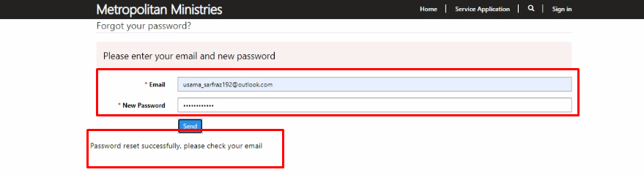

User will receive an email like below:

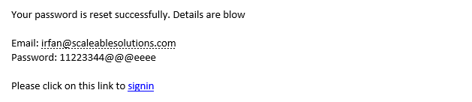

Advanced Form:

As per advanced form, on first step of service application contact is being create, flow named “contact in progress” is triggering, it will complete its functionality, and will send an email to user after delay complete. User will receive the portal service application link where he left his application.   
  
Browsers sessions are used into advanced form, by-default always new form was opening when user open service application webpage, but now we have update this, user can continue with his old session.

But if user clear the cache and open the link on other browser he will start new session, old session will not be start.